Catherine E. Pugh Room 250
Mayor City Hall
Baltimore, MD 21202

M E M O R A N D U M: April 7th, 2017

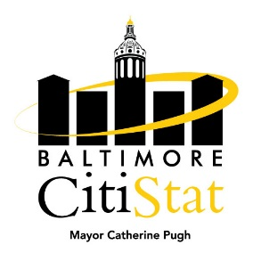
TO: The Honorable Mayor Catherine E. Pugh
Peter Hammen, Chief Operating Officer
Tisha Edwards, Chief of Staff
Jim Smith, Chief of Strategic Alliances
Terry Hickey, Mayor’s Office of Human Services
Sameer Sidh, Director of CitiStat

FROM: CitiStat Team

SUBJECT: Homelessness Stat Meeting Summary Briefing

Making Progress

- Data Quality. After last month’s meeting, the Mayor’s Office of Human Services (MOHS) provided the following update regarding Fiscal Year 2016 data submissions to HUD (due on Mary 31st, 2017) for federal funding. In terms of progress, increased provider usage of HMIS across the City will aid in federal funding applications.

  - “Over the next two months the HMIS team will be working heavily with providers to review and clean Federal FY16 data for submission to HUD at the end of May. HUD System Performance Measures, which align closely to CitiStat data, are due on May 31st. For this reason, FY16 data may shift, MOHS will rerun and update all FY16 data once the data review is complete.”

- Street Outreach Pamphlets. At the meeting, the Baltimore City Police Department (BPD) stated that patrol officers often interact with homeless individuals within their Districts, whether it is in response to a 311 Service Request or a call for service. The panel discussed distributing the Street Outreach Information Card (located at http://human-services.baltimorecity.gov/homeless-services/documents) at the District level, allowing patrol to provide relevant information to homeless individuals. The panel also discussed further simplifying the card.

Needs Improvement

- Returns to Homelessness. The panel discussed the need to further study those providers and programs with the highest returns to homelessness after individuals exit to permanent housing. The panel also discussed whether any progress had been made with regards to increasing the number of permanent housing beds Citywide (see table on the next page).

